Post 1: 25 TDA Dates & Appreciation Events (Truck Driver Appreciation Week Sept. 13-19 & Louisiana Appreciation Events List)
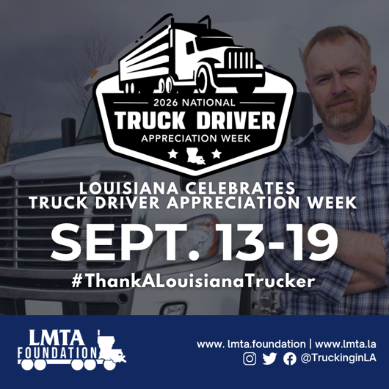
*Post or schedule on social media Sunday, Sept 13
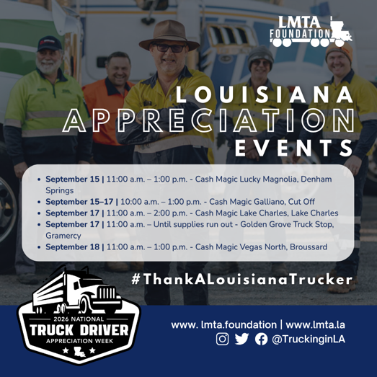
(Post both graphics) Facebook Post:
This week, Sept. 13-19, is #NationalTruckDriverAppreciationWeek!

Professional truck drivers are the key link in our nation’s supply chain, keeping Louisiana and America moving every single day.

Throughout the week, LMTA members are hosting Truck Driver Appreciation lunches and celebrations across the state! Drivers, check out a stop near you:

DENHAM SPRINGS | SEPT. 15
Cash Magic Lucky Magnolia
11 a.m. - 1 p.m. or while supplies last
Presented by Cash Magic & Razorback Rentals

GALLIANO | SEPT. 15-17
Cash Magic Galliano
10 a.m. - 1 p.m.
Presented by Cash Magic & ACME Truck Lines

LAKE CHARLES | SEPT. 17
Cash Magic Lake Charles
11 a.m. - 2 p.m.
Presented by Cash Magic, J. Guillory Jr. Trucking LLC & Lake City Trucking

GRAMERCY | SEPT. 17
Golden Grove Truck Stop
11 a.m. until they run out
Presented by Frisard Companies & Golden Grove Truck Stop

BROUSSARD | SEPT. 18
Cash Magic Vegas North
11 a.m. - 1 p.m.
Presented by United Vision Logistics

Stop by, grab a meal and help us celebrate the professional truck drivers who keep Louisiana moving!

#NTDAW26 #ThankALouisianaTrucker #ThankATrucker #NothingWithoutTrucking

(Post both graphics) Twitter Post:
Sept. 13-19 is National Truck Driver Appreciation Week!

LMTA members are hosting appreciation lunches across Louisiana to thank the professional drivers who keep our state moving.

Find a celebration near you: https://members.lmta.la/eventcalendar/Details/sep-13-national-truck-driver-appreciation-week-1876645?sourceTypeId=Website

#NTDAW26 #ThankALouisianaTrucker

Post 2: Truckers Move America Forward
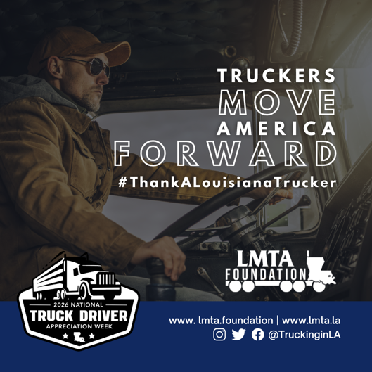
Post or schedule on social media Monday, Sept. 14
Facebook Post:
Truckers Move America Forward.

From the food on our shelves to the fuel in our tanks and the materials that keep Louisiana businesses running, professional truck drivers deliver the goods our communities depend on every day.

During #NationalTruckDriverAppreciationWeek, we recognize the hardworking men and women behind the wheel who keep Louisiana connected, our economy moving and America moving forward.

Take a moment this week to #ThankALouisianaTrucker.

#NTDAW26 #NothingWithoutTrucking #ThankATrucker

Twitter Post:
Truckers Move America Forward.

From the food on our shelves to the materials that keep businesses running, professional truck drivers deliver what our communities depend on every day.

This #NationalTruckDriverAppreciationWeek, #ThankALouisianaTrucker.

#NTDAW26 #NothingWithoutTrucking #ThankATrucker

Post 3: Jobs Facts (Over 93,000 Jobs in Louisiana…)
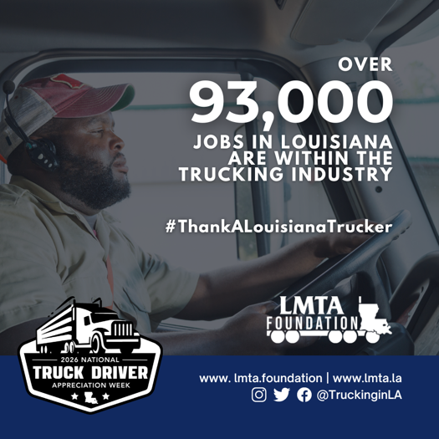
Post or schedule on social media Tuesday, Sept. 15
Facebook Post:
Trucking means jobs for Louisiana.

More than 93,000 jobs across our state are supported by the trucking industry. Behind that number are professional drivers, technicians, dispatchers, safety professionals and countless others working every day to keep Louisiana moving.

During #NationalTruckDriverAppreciationWeek, we’re especially proud to recognize the professional drivers at the heart of this essential industry.

Thank you for the work you do and the role you play in keeping Louisiana’s economy moving.

#NTDAW26 #ThankALouisianaTrucker #NothingWithoutTrucking #ThankATrucker

Twitter Post:
Trucking means jobs for Louisiana.

More than 93,000 jobs across our state are supported by the trucking industry. During #NationalTruckDriverAppreciationWeek, we recognize the professional drivers who help keep Louisiana’s economy moving.

#NTDAW26 #ThankALouisianaTrucker #NothingWithoutTrucking #ThankATrucker

Post 4: Tons Moved by LA Truckers (Louisiana Truckers Transport Over 170,450)
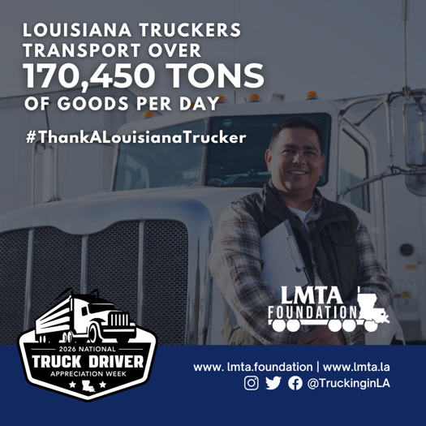
Post or schedule on social media Wednesday, Sept. 16
Facebook Post:
Every day, Louisiana truckers deliver.

More than 170,450 tons of goods are transported by truck across Louisiana each day, helping stock our stores, supply our businesses and keep our communities running.

During #NationalTruckDriverAppreciationWeek, we recognize the professional drivers behind those deliveries. Mile after mile and load after load, their work keeps Louisiana moving.

Thank you to the truckers who deliver for our state every day.

#NTDAW26 #ThankALouisianaTrucker #NothingWithoutTrucking #ThankATrucker

Twitter Post:
Every day, Louisiana truckers deliver.

More than 170,450 tons of goods are transported by truck across our state each day, keeping businesses supplied and communities moving.

This #NationalTruckDriverAppreciationWeek, #ThankALouisianaTrucker.

#NTDAW26 #NothingWithoutTrucking #ThankATrucker

Post 5: Communities Depend on Trucking (78% of Louisiana’s communities…)
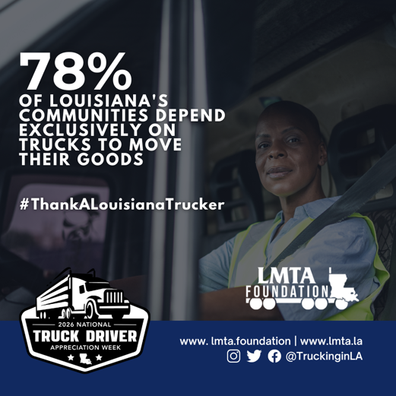
Post or schedule on social media Thursday, Sept. 17
Facebook Post:
Louisiana communities depend on truckers.

In fact, 78% of Louisiana communities rely exclusively on trucks to deliver the goods they need. From everyday essentials to the supplies that keep local businesses operating, professional truck drivers connect communities across our state.

During #NationalTruckDriverAppreciationWeek, we recognize the drivers who make those deliveries possible and keep Louisiana moving every day.

#NTDAW26 #ThankALouisianaTrucker #NothingWithoutTrucking #ThankATrucker

Twitter Post:
78% of Louisiana communities rely exclusively on trucks to deliver the goods they need.

During #NationalTruckDriverAppreciationWeek, we recognize the professional drivers who keep our communities supplied and Louisiana moving.

#NTDAW26 #ThankALouisianaTrucker #NothingWithoutTrucking #ThankATrucker

Post 6: Trucking Companies is Louisiana (There are over 10,500 trucking companies...)
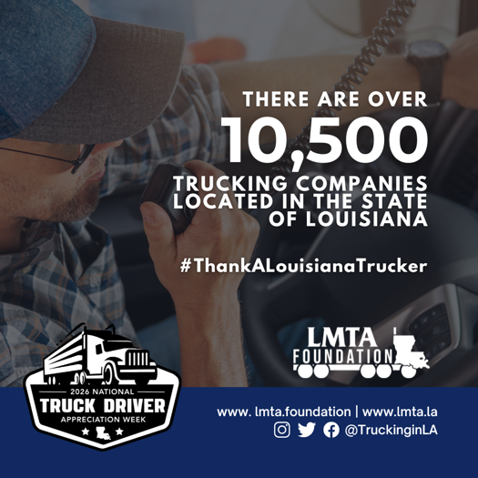
Post or schedule on social media Friday, Sept. 18
Facebook Post:
Louisiana’s trucking industry is powered by businesses of all sizes.

More than 10,500 trucking companies operate across our state, many of them small businesses and single-truck operations. These companies and the professional drivers behind them work every day to serve our communities, support local economies and keep Louisiana moving.

During #NationalTruckDriverAppreciationWeek, we’re proud to recognize the people and businesses that make trucking such an important part of Louisiana.

#NTDAW26 #ThankALouisianaTrucker #NothingWithoutTrucking #ThankATrucker

Twitter Post:
More than 10,500 trucking companies operate in Louisiana, many of them small businesses and single-truck operations.

This #NationalTruckDriverAppreciationWeek, we recognize the businesses and drivers keeping Louisiana moving.

#NTDAW26 #ThankALouisianaTrucker #NothingWithoutTrucking #ThankATrucker

Post 7: Thank you Truckers (Truckers thank you for delivering for…)
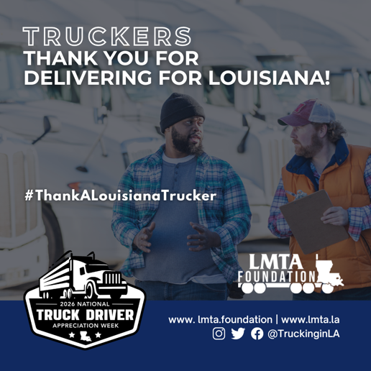
*Post or schedule on social media Saturday, Sept. 19
Facebook Post:
As National Truck Driver Appreciation Week comes to a close, our appreciation doesn’t end here.

Every day, Louisiana’s professional truck drivers deliver for our families, businesses and communities. They keep our shelves stocked, our economy moving and our state connected.

To every professional driver who puts in the miles and keeps Louisiana moving: thank you for delivering for Louisiana, this week and every week.

#NationalTruckDriverAppreciationWeek #NTDAW26 #ThankALouisianaTrucker #NothingWithoutTrucking #ThankATrucker

Twitter Post :
As #NationalTruckDriverAppreciationWeek comes to a close, our appreciation doesn’t end here.

To every professional driver who puts in the miles and keeps our state moving: thank you for delivering for Louisiana, this week and every week.

#NTDAW26 #ThankALouisianaTrucker #NothingWithoutTrucking #ThankATrucker

